SWE20001 – Managing Software Projects

Learning Summary Report

S M Ragib Rezwan (103172423)

**Portfolio Submission Due**

All Grades: Week 14 Mon (6th June 2022), 9:00am

**Portfolio Interview Dates**

Distinction / High Distinction: Week 14 Tue – Fri (7th – 10th June 2022), (15 minutes per student)

Self-Assessment Details

The following checklists provide an overview of my self-assessment for this unit.

|  |  |  |  |  |
| --- | --- | --- | --- | --- |
|  | Pass (D) | Credit (C) | Distinction (B) | High Distinction (A) |
| Self-Assessment (please tick) |  |  |  | X |

*Self-assessment Statement*

|  |  |
| --- | --- |
|  | Included (please tick) |
| Learning Summary Report | X |
| **All** Pass Tasks are Compete in Doubtfire | X |

*Minimum Pass Checklist*

|  |  |
| --- | --- |
|  | Included (please tick) |
| All Credit Tasks are Complete on Doubtfire | X |

*Minimum Credit Checklist, in addition to Pass Checklist*

|  |  |
| --- | --- |
|  | Included (please tick) |
| Interview booked | X |
| All Distinction Tasks are Complete on Doubtfire | X |
| Other pieces (please specify) |  |

*Minimum Distinction Checklist, in addition to Credit Checklist*

|  |  |
| --- | --- |
|  | Included (please tick) |
| Software Project Document [Plan, Design, QA] meet HD criteria and standards | X |
| Research Article / Essay meets HD criteria and standards | X |
| Other pieces (please specify) |  |

*Minimum High Distinction Checklist, in addition to Distinction Checklist*

# Declaration

I declare that this portfolio is my individual work. I have not copied from any other student’s work or from any other source except where due acknowledgment is made explicitly in the text, nor has any part of this submission been written for me by another person.

Signature: Ragib

# Portfolio Overview

This portfolio includes work that demonstrates that I have achieved all Unit Learning Outcomes for SWE20001 Managing Software Projects to a **High Distinction Grade** level.

For instance, in this course I understood several new and interesting concepts from the lectures, like: software development life cycle and its different variations, Scrum SDLC process and its subdivisions (like product backlog, sprint, sprint meeting, etc), Scope of a project, Different work break down structure and estimation techniques (analogy, size and Delphi,), identifying, categorising and mitigating risk(wherever possible), detailed documentation, quality analysis using ISO25010 characteristics and sub characteristics, architectural software design, KoST (Knowledge, skill, technology), Definition of done and consequence of not following it, proper Project proposal writing, Burndown chart usage, task scheduling, tracking and monitoring, etc. All of these can be clearly seen in all the tasks linked here in this portfolio (01P-23P, 61-64C, 71-73D, 81-82HD) as I had utilised those concepts there to analyse the project that me and the team had produced in different points in time (during project proposal, during Sprint1, during Sprint2)

Furthermore, by participating in a team to develop a software (from a given scenario) in two consecutive Sprints of Scrum, I have also acquired firsthand experience of how software developers work following the scrum method (02P,04P,06-07P,08-14P,16-22P), including all the different soft techniques used in details, alongside their pros and cons in terms of motivation, productivity and efficiency. Not only that, I have also come into contact with several different types of design patterns, algorithm, backend logic, frameworks, GitHub usage, etc while coding alongside my team mates, which have further honed my knowledge and skills, opening my eyes to new possibilities.

This can be noticed if you go through my tasks from the very first 01P task, where I didn’t even know what scope was, to the very end HD tasks (81-82HD) where I not only wrote my own project proposal (including Scope, Deliverables, Product Backlog, Software Quality using ISO25010), alongside WBS and effort estimation for Sprint 1 with justification for a chosen scenario (81HD), but have also went a step beyond to compare Scrum (agile SDLC) with Waterfall (traditional SDLC) in terms of completing the previously mentioned project in the project proposal (82HD), using the knowledge I have developed for Scrum in this unit and different research papers (with proper referencing) for Waterfall SDLC.

Thus with this portfolio, I believe that I have not only achieved all Unit Learning Outcomes, but also have extended beyond the material presented, making me eligible for High Distinction.

# Reflection

## The most important things I learnt:

The most important thing I learnt throughout the course is to have trust in others in the team and to delegate tasks effectively. Although this might seem like a simple concept, it’s actually an extremely difficult one to accomplish, especially for me. That’s because I have always been in groups where I had to micromanage everything while the rest just slacked off. Thus I had become used to doing everything by myself. Thus in this course I had ended up wasting a lot of time at first trying to do things my way instead of trusting the way suggested by my group mates. But once I got used to it, I started to take a step back and instead of actively pushing people to do things my way, I started to listen to them and modify my approach to listen to them. Thus, I finally began to delegate tasks to my team mates instead of doing everything by myself and have been able to achieve a sense of peace that I had never felt before in groupwork tasks.

## The things that helped me most were:

There were several things in this unit that had helped me. But, among them, two factors stood out the most:

A) Tutor’s feedback on tasks:

For me the concepts taught in the unit was quite interesting and fun. But unfortunately English had not been my native tongue. Thus I would always mess up trying to explain my understandings in writing analysis type writings. So, having Naveed as my tutor helped me a lot as he would keep on giving me resubmits with detailed feedback and would also find time to do one on one consultations with me to ensure I fully understand what my mistake in the writing is and how to correct it. This provided me the support and backing which further encouraged me to go for both HD tasks

B) Teammates motivation, support and advice:

They helped me not only understand and correct my mistakes in terms of approaching group work, but have also helped me code more elegantly by opening my eyes to new possibilities by using different design patterns, architecture diagrams, etc. Furthermore, most of my group mates are currently doing capstone projects where they are working on industrial project using similar techniques. This in turn helped me develop an interesting insight by listening to their experience in the group and how these techniques are helping them develop their projects more effectively and efficiently.

## I found the following topics particularly challenging:

For me the most challenging thing was the DOD (Definition of Done). That’s because there the slides had little info while most of the information was in video format given by Ken. Thus I had pause and rewind noting down important and unique points instead of relying much on the notes (unlike other slides where the key points had been noted in the slides and thus only needed to listen to the lecturer while linking his words to those key points)

## I found the following topics particularly interesting:

The thing that I had found most interesting was the WBS (Work Break Down structure) part. It is basically different ways to break a task down into discrete subtasks in order to set an estimate for it. This was quite unique to me as I before I had been considering each product backlog as their own simplest unit (as they were similar to tasks that had been given to me previously in other doubtfire units (like OOP) and had been drawing up vague estimation based on the times it took me to complete those tasks in those previous units.

Unfortunately, these estimates would usually be off by several hrs. Thus, learning about WBS has helped broaden my understanding and find more accurate ways to estimate the time it takes to accomplish a task which is quite useful!

## I feel I learnt these topics, concepts, and/or tools really well:

I believe I have learnt Scrum, Project planning, Scope, Product backlog, WBS, Sprints, etc very well which can be clearly seen in my HD1 task where I used all of them to develop my project plan and sprint 1 for a chosen scope there

## I still need to work on the following areas:

Well although I learnt most of the concepts well, I believe I need to spent more time on DOD (definition of done) as that was too focused on video done by Ken and thus I am uncertain whether I had noted everything properly or not.

## My progress in this unit was …:

Here, at first my progress is quite slow. That is because of a couple of reasons:

1. This had been my first semester abroad, away from my parents (as I had done my previous course in my home country). Thus it took me some time to get used to my current surroundings and get everything in order.
2. Furthermore, this unit is heavily dependent on group work. But unfortunately, me and my teammates took some time to realise that, which resulted in me having my individual tasks done in advance, but ending up being delayed in the group tasks, which in turn showed up as delay in the burndown chart in doubtfire.

But as the months went by, me and the team started to understand how the unit worked and what had been required of us. Thus we started to try and keep to the schedule provided to us in the All-Portfolio.html webpage. But unfortunately, my teammates were in financial issue due to political unrest in their home country and thus were mostly busy working in order to even get their tuition fees for the current semester. Thus it took them more time to finish their parts in the group tasks, which in turn delayed the pace. But luckily, they had managed to earn up the money they needed and were able to start properly focusing on the unit near the end of April, which is when the productivity had drastically increased (as seen in the burndown chart). Thus by the end, not only had we been able to finish all the group tasks properly, but I had also been able to work on and submit all of my D and HD tasks in time (which can be seen in the picture below).

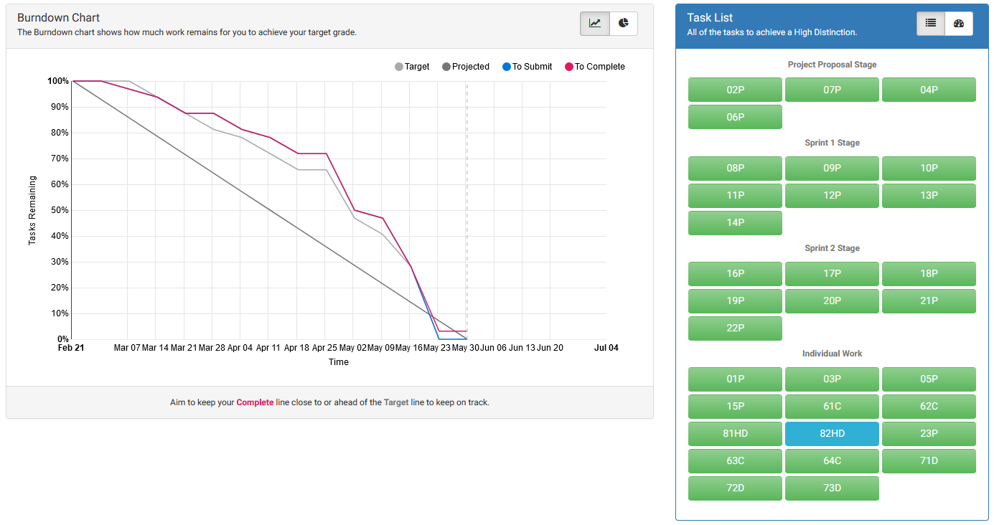

## This unit will help me in the future:

This unit will help me a lot in the future especially in terms of team work and multi-coding (ie coding in a team) aspects. Unfortunately, I am not really certain whether I will ever use Scrum after this as my major is cyber security and chance of me developing software in my future work environment is quite slim. But, the insights I got while doing this course and following the scrum and sprints will definitely help me if I ever come across a scenario where I will be in a team to develop a software.

## If I did this unit again I would do the following things differently:

Well, If I did this unit again, I would start working from the very start and not procrastinate. Furthermore I would take at least an hr to go through each of my work before submitting, in a clear and calm manner, and just proof read it, instead of submitting the tasks as fast as possible. That way I will not only avoid making silly mistakes, but also be able to have a more professional outlook in my writings.